The Exemplary Life of Ozbekali Zhanibekov: Memories of Those Who Knew Him
In accordance with the event plan of the Young Scientists’ Council for the 2026–2027 academic year, a scientific and educational meeting entitled «The Exemplary Life of Ozbekali Zhanibekov: Memories of Those Who Knew Him», dedicated to the 95th anniversary of the birth of statesman, public figure, and prominent advocate of national culture Ozbekali Zhanibekov, was held.
Date: September 30, 2026
Venue: D. Isabekov Hall
Organizer: Young Scientists’ Council
The purpose of the event was to promote the exemplary life and public service of Ozbekali Zhanibekov, a statesman and public figure who made a significant contribution to the preservation of national culture and historical heritage; to introduce the younger generation to his work in the fields of culture, history, and the preservation of national values; and to reveal his human and civic qualities through the memories of people who personally knew him.
The scientific and educational meeting was attended by young scientists, lecturers, and students of the university. Special guests of the event included Serim Aiganym Abankyzy, Honorary Citizen of Turkistan, and Zhuzybayeva Rakhia Suleimenkyzy, Honored Worker of Culture of the Republic of Kazakhstan and specialist of the Department of Exposition and Exhibition Activities of the «Aziret Sultan» National Historical and Cultural Museum-Reserve.
During the meeting, participants were provided with comprehensive information about Ozbekali Zhanibekov’s life, state and public service, his contribution to the development of national culture, as well as his work aimed at preserving and promoting historical and cultural heritage.
The main distinctive feature of the event was that Ozbekali Zhanibekov’s life and activities were presented through the memories of people who personally knew and witnessed his work. The special guests shared their memories and spoke movingly about the statesman’s human qualities, diligence, concern for the history and culture of the country, and civic commitment to promoting national values.
In her speech, Serim Aiganym Abankyzy, Honorary Citizen of Turkistan, highlighted Ozbekali Zhanibekov’s contribution to shaping the historical and cultural image of Turkistan, his special attitude toward national heritage, and the significance of the spiritual legacy he left for future generations. Her memories enabled students to gain a deeper understanding of the historical figure’s activities during that period.
Zhuzybayeva Rakhia Suleimenkyzy, Honored Worker of Culture of the Republic of Kazakhstan and specialist of the Department of Exposition and Exhibition Activities of the «Aziret Sultan» National Historical and Cultural Museum-Reserve, spoke about activities related to museum work and the preservation and promotion of historical and cultural heritage. She also shared her views on Ozbekali Zhanibekov’s role in protecting national values and honoring historical monuments. In addition, she shared meaningful memories of his sense of responsibility toward cultural heritage and his respect for the history of the country.
During the meeting, students asked special questions, and an open exchange of views with the guests was organized. Students received answers to questions that interested them concerning Ozbekali Zhanibekov’s personality, his contribution to national culture, the protection of historical monuments, and his activities aimed at passing cultural heritage on to future generations.
During the event, it was emphasized that Ozbekali Zhanibekov’s exemplary life serves as an important model for the younger generation in terms of civic responsibility, respect for national values, concern for the history of the country, and the preservation of cultural heritage. It was also noted that the memories of those who knew him personally make it possible to gain a deeper understanding of the historical figure not only through official sources, but also through his human qualities, life principles, and relationships with his contemporaries.
At the end of the scientific and educational meeting, the organizers expressed their gratitude to the special guests and presented Serim Aiganym Abankyzy and Zhuzybayeva Rakhia Suleimenkyzy with commemorative gifts. The guests were thanked for their contribution to promoting historical and cultural values among the younger generation, introducing young people to the history of the country, and preserving the exemplary legacy of Ozbekali Zhanibekov.
Following the meeting, the participants emphasized the importance of further promoting Ozbekali Zhanibekov’s life and public service among young people, conducting scholarly research into his contribution to the preservation of national culture and historical heritage, and continuing to organize educational meetings aimed at collecting the memories of people who personally knew him and passing these valuable memories on to future generations.

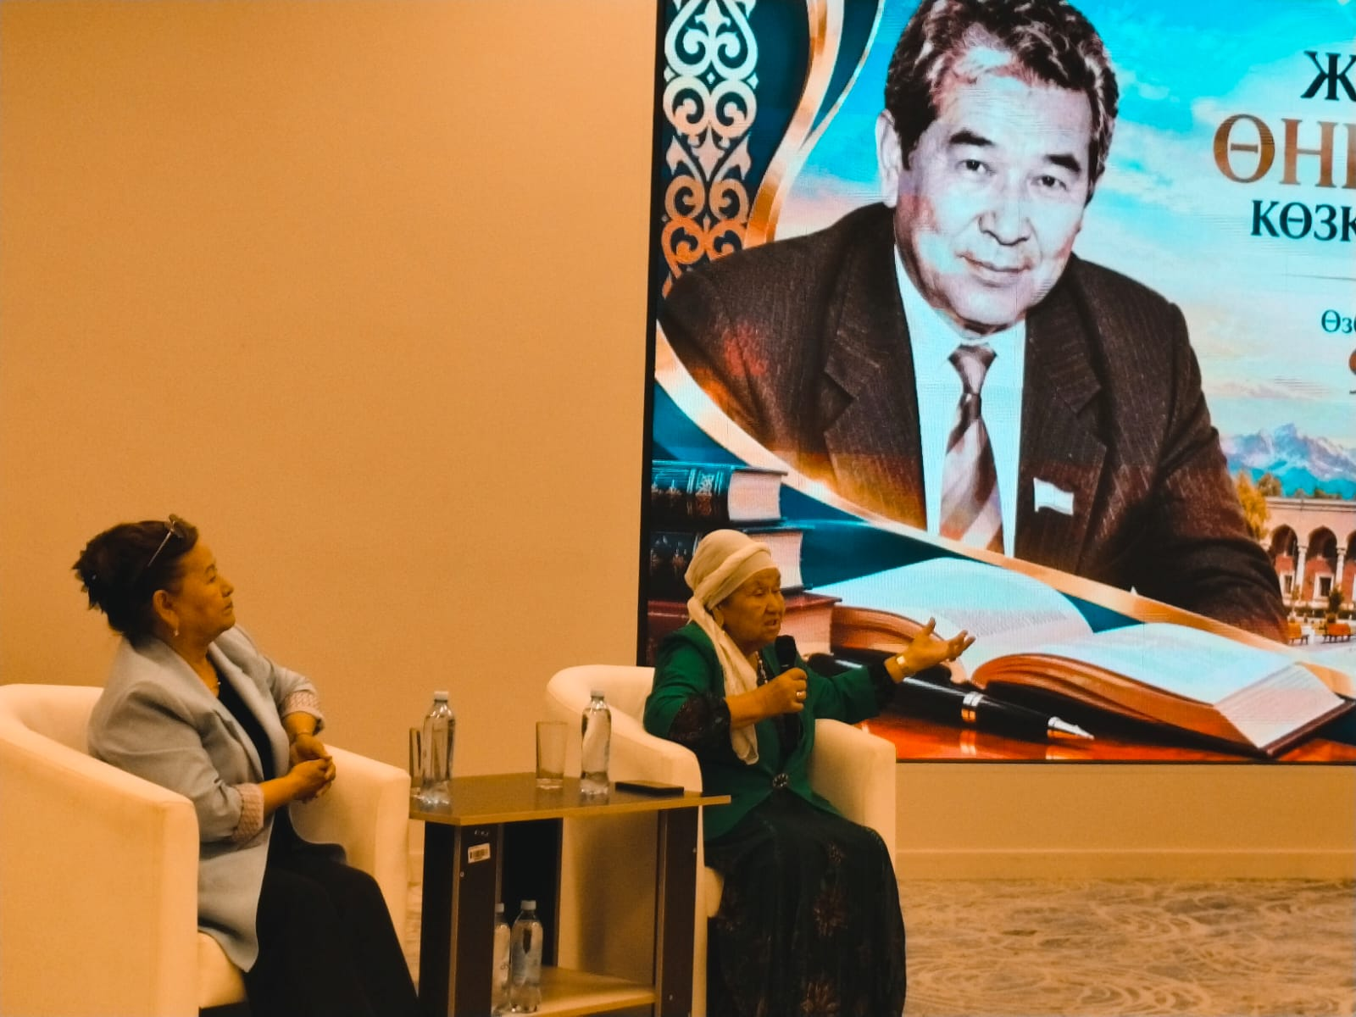

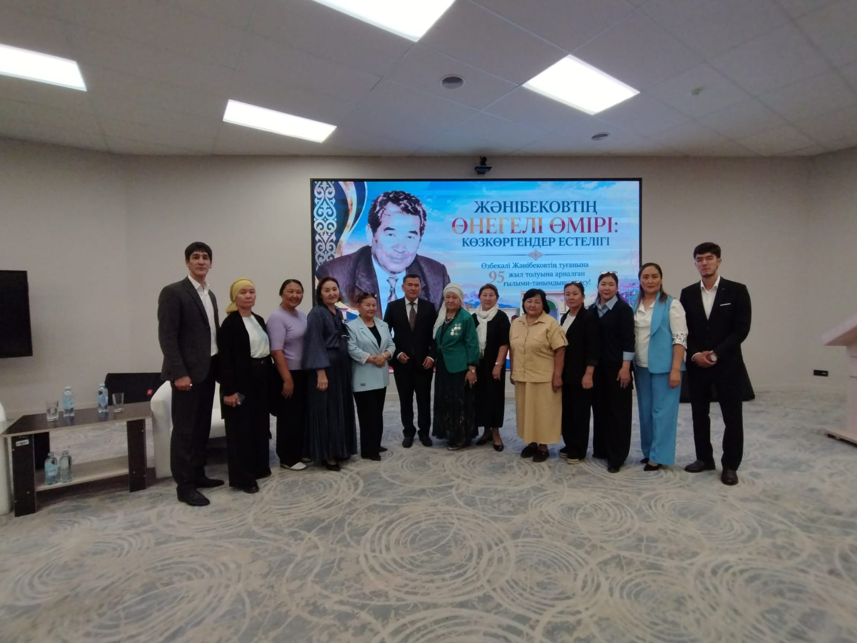

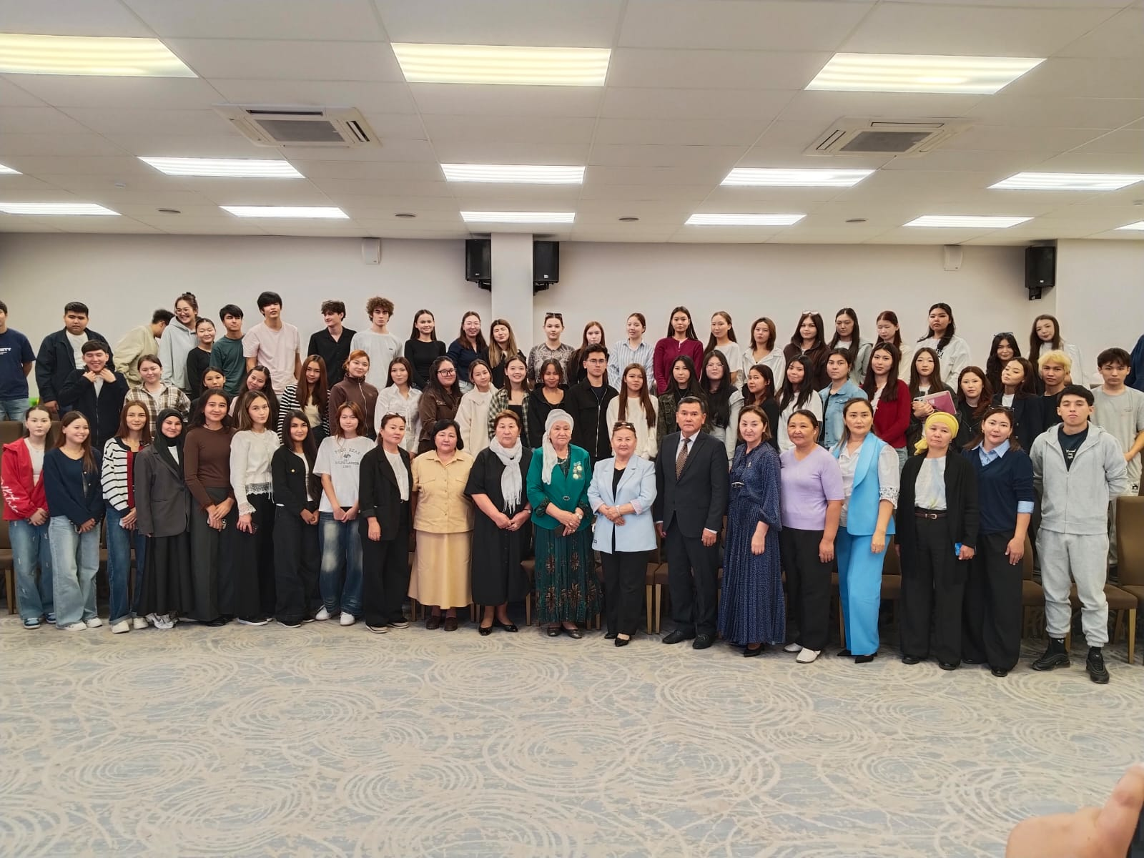

Chairman of the Council of Young Scientists / A. Kozhan

